Operating Systems Lab Sheet 3 Exercises

Jack Carroll

T00194823

**Exercise 1**

List the applications (if any) that are running: Document 1 – Word, Labs Folder, Resource Monitor, 03-Looking at System Performance [Read-Only Memory] [Compatibility Mode] – Word

From the Processes tab, specify

The process using the maximum amount of memory: SavService.exe *32

From the Performance tab, specify

The number of processes: 85

The total amount of physical and virtual memory currently in use by the operating system and all programs.: 3 GB

Total amount of physical and virtual memory available on the computer: 16 GB

Total physical memory i.e. RAM: 8000 GB

The available RAM: 5061 MB

Amount of RAM used for System Cache: 5043 MB

For the kernel: (i.e. operating system)

Paged memory: 497 MB

Nonpaged **memory:** 194 MB

What is ratio of Total commit charge to Total Physical Memory?: 5.3/8.6 GB

From the Processes tab:

Check the Show processes from all users if it is not already checked.

Specify any System process: Google Chrome

Specify any Local Service: Diagnostic Service Host

Specify any Network Service: Network Location Awareness

Note: The System Idle Process is not a process, more a counter which is displayed in Task Manager used for measuring how much idle time the CPU is having at any particular time.

How much CPU time is used by System Idle Process?: 7 hours 26 minutes

**Exercise 2**

Start two separate instances of the **notepad** application. (Start, Type notepad.exe just above the start button in the text box that has “Search all programs and files”, then hit return OR click the ‘New Task’ button on the applications tab and type in Notepad.exe). Confirm that the Task Manager Applications tab shows both applications running.

Right click on one instance of Notepad in the Applications tab. Choose Go To Process

What is the corresponding process?: notepad.exe

What is the total amount of physical and virtual memory now in use by the operating system and all programs?: 5 GB

Verify that it is larger than the value above, before Notepad was run.

In the Applications tab select one of the notepad applications and then click the ‘Switch to’ button. Describe what happens.: The Task Manager minimises and the instance which the application is connected to appears on the screen which takes you to the instance.

Then click the ‘End Task’ button and describe what happens.: The instance which you end closes and one application which is running remains.

Finally start an instance of **WordPad** using the ‘New Task’ button. Type in WordPad.exe

Verify that all applications appear in Applications tab.

**Exercise 3**

Select the Processes tab. Identify the process that is using most of the CPU time. chrome.exe

**Exercise 4**

Create a simple java (or basic program) with an infinite loop that repeatedly performs some simple math calculation.

while (true)

simple calculation

Run this program.

**Note: java.exe is the process that is running while your java program is executing.**

What is the percentage of CPU time your program is using. Explain the result.

38.6% (2)

The percentage increases rapidly as the numbers keep on going to infinity within the loop when the program has run. This leads to the lack of response from java.exe due to the infinite loop which does not end at a certain value.

You can see the CPU time used by the operating system. To do this select the menu item View, then Show Kernel Times to add an additional kernel related red line to the graph.

How much CPU time is used by the operating system while your java program is running.: 00:01:39

Now add code to do output inside your loop e.g. System.out.println(“Hello World”)

How much CPU time is now used by the operating system while your java program is running. Explain your answer.

00:00:03

The CPU time is very low as the time is stalling due to the infinite loop of “Hello World” which does not end at a certain point. This results in the CPU struggling to control the java.exe program as the program ceases the function of the java.exe program where it stalls. Therefore, the time moves up extremely slowly.

Run the program with the infinite loop 4 times. i.e. open your IDE 4 times and create and run the same program.

What is the percentage of CPU time is now being used by your processes. Explain the result.

53%

The CPU time increases because of the CPU having difficulty to handle all four java programs simultaneously. It leads to the CPU becoming more difficult to handle to boost the computer’s performance which results in the java programs ceasing to function.

Run it another time so that now your infinite loop is running 5 times. What is the percentage of CPU time is now being used by your processes. Explain the result.

81%

The CPU time substantially increases due to the CPU’s struggle to handle all five java programs simultaneously. This results in the CPU becoming more difficult to handle to boost the computer’s performance which results in the java programs ceasing to function.

**Exercise 5**: Run the infinite loop program. When the program is running, assign it to one processor, say CPU 0. To do this, right click on the java.exe process in Processes tab, and choose Set Affinity.. Select CPU 0 only.

What is the percentage of CPU time the java.exe process is using? Explain the result.

34.1% (2%.)

Surprisingly, the java.exe program is only using 2% of the CPU time as the seconds of the program move up quite slowly due to the output’s infinite loop. This results in the crashing of the JCreator application even though the java.exe program is still running.

Run the infinite loop program another time and again assign the process to CPU 0 only.

What is the percentage of CPU time the two java processes are using? Explain the result.

67% (4%)

The two java.exe programs have a higher percentage of CPU time because of the computer’s difficulty in controlling both programs at once. It causes the JCreator applications to malfunction due to the two infinite loops that are running. It causes complications for the computer because of the infinite loops.

**Exercise 6:**

Create a simple java (or basic program) that requests the user to input some value. Use JOptionpane.showInputDialog, or similar, to ask for input in Java.

Run this program. Let it wait for input. Check the Processes tab of the Task Manager and identify the process and write down the percentage of CPU time it is using. Explain the result.

1.8% (0.2%)

The result of the input causes the CPU time to increase slightly as the more numbers you type, the higher the CPU time will be as it processes the input that is written. When the program is waiting for input, the CPU time percentage is very low because the program is blocked where it is waiting for input/output completion.

**Exercise 7:**

Select the Performance Tab. Select the menu item View, Show Kernel Times’ to add an additional kernel related red line to the graph. Run Notepad again. Put TaskManager window over Notepad window. Click and hold the left mouse button over the Notepad window title. Move the window rapidly over around the screen and watch the CPU usage graph change. Explain what is happening. Look at what is happening in Processes tab in CPU column also.

The CPU usage is increasing due to the mouse wiggling the Notepad window. Once the mouse stopped moving the Notepad window, the CPU usage was reduced back to 0% as the mouse carried out an input/output completion with the mouse. Therefore, this puts up the kernel time for the CPU Usage as the CPU works harder to detect and sense the mouse shaking the Notepad Window. The CPU within the processes was increased to 1% of CPU Usage due to the computer processing the mouse movement of the Notepad.exe process when the process is running.

**Exercise 8:**

Specify for the kernel: (i.e. operating system**)**

Paged memory 502 MB

Nonpaged memory200 MB

Start 5 instances of **Wordpad** and describe. Now specify kernel level memory.

Paged 503 MB

Nonpaged201 MB

Explain what has happened.

The paged memory is incremented by one. However, the nonpaged memory remains the same most of the time as it fluctuates between one MB, e.g. 200/201 MB. Most of the physical memory is unused by the kernel when this action occurs. When 5 notepad instances are opened, the amount of virtual memory used by the kernel increases the memory.

**Exercise 9**

**Looking at System process, Local Services and Network Service.**

As well as user processes, there are Local Services, Network Services and System processes running.

In the Processes tab, you can add extra columns by choosing View menu option, then Select Columns.. and check any column you want to add. Add the Description column.

Find the following information in the Processes tab:

**System processes**

Name of any system process: WINWORD.EXE

Description of this process: Microsoft Word

**Local Service**

Name of Local Service: WinHttpAutoProxySvc

Description of service: WinHTTP Web Proxy Auto-Discovery Service

**Network Service**

Name of Local Service: PolicyAgent

Description (summary) of service: IPsec Policy Agent

**Click on the Performance Tab**

Click on **Resource Monitor** button. Investigate the different tabs.

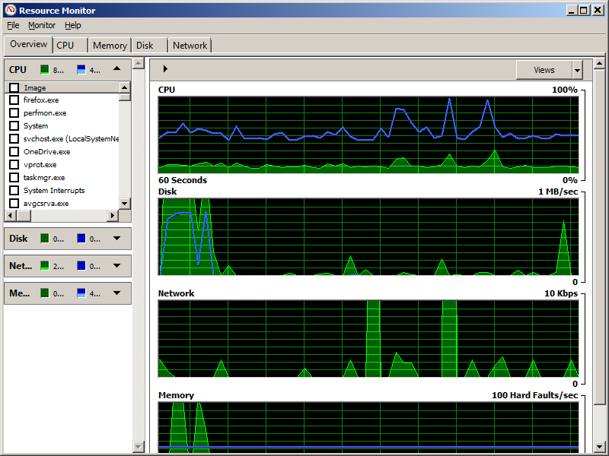

**Click on the Networking Tab**

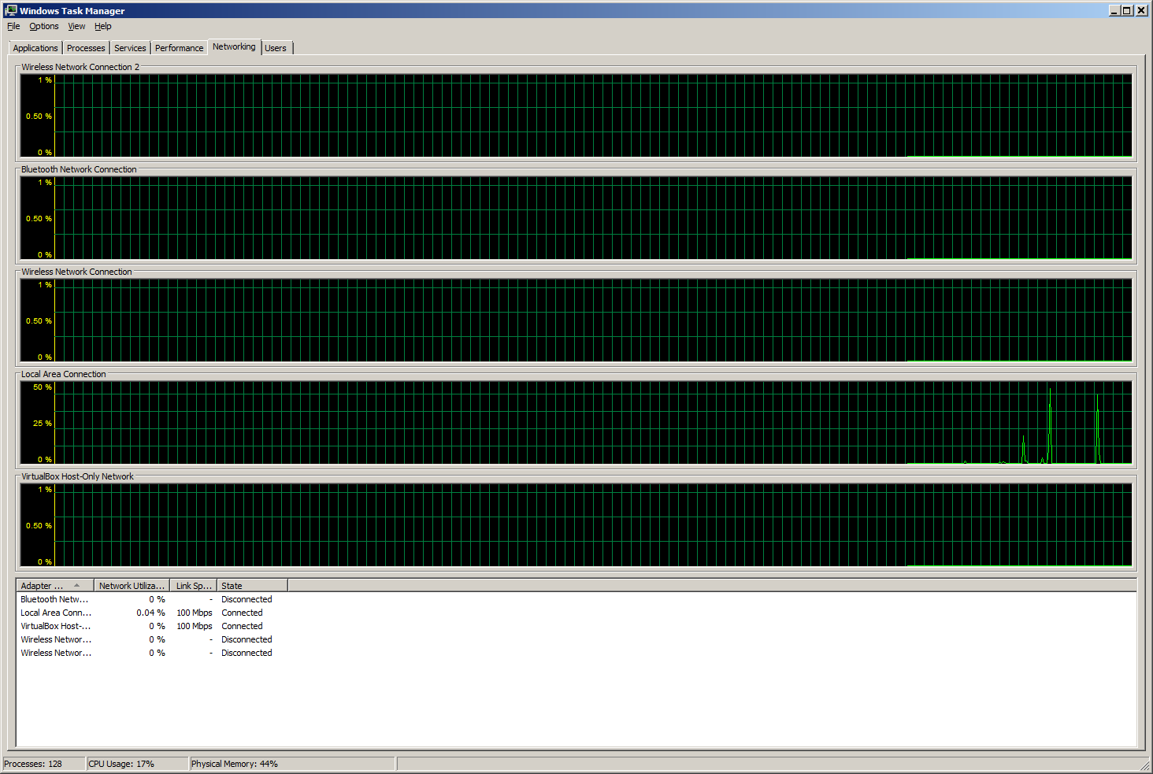

What is the link Speed? 1 Gbps

**Click on the Users tab**

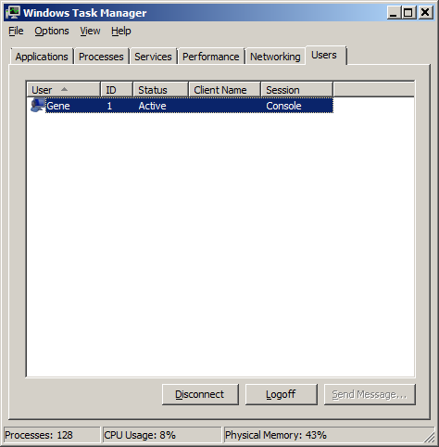

What actions can you perform on users from here? You can manage the user accounts that are on the computer, the user’s current actions and the applications that are currently running on the computer are shown when you expand the user menu in Task Manager. The user can be disconnected from this menu which will result in the Task Manager no longer showing the user as he or she is disconnected. This can lead to logging off a user.